**Case Study: The Consumer Rebirth of LEGO**

Founded in 1949, Danish toymaker LEGO is one of the world’s enduringly iconic brands, synonymous with childhood and playtime for many children. LEGO offers a vast range of themed sets of building blocks, theme parks, computer games, television and movies, board games, magazines and books, and robotics. Although valued at US$7.1 billion today, as recently as 2004 the brand was described as “near bankruptcy” by then executive vice president of marketing Mads Nipper (see Wikipedia, “History of Lego Decline”). Failing to respond to the rise in electronic gaming, reduction in children’s playtime, and a declining birth rate in Western countries, the company was on borrowed time. So what went right?

Like this book’s author, most children grew out of LEGO at a certain age, moving on to more typical teenage pursuits (music, movies, fashion, parties, and romance). However, some adults continued their love affair with LEGO. Communities of adult users formed spontaneously around the brand, ordering one type of brick in huge quantities, creating building competitions (sometimes involving a blind bag of blocks that had to be shaped into something in a fixed period of time). As the Internet developed, user groups began to form, posting figures of their creations online, as well as hacks for the brand’s robotic line Mindstorms.

One problem for the brand was that the initial excitement of receiving a LEGO set gave way to boredom as many children completed the model described in the instructions and then asked “What now?” Sets were passed to the next generation, thrown out, sold on, or given to other families with children. Adult users, however, went beyond the instructions, viewing the brand as raw material for their own creative visions. Artists also began to use the brand as raw material for creative works, while others developed LEGO-based jewellery, notebook covers, and other unofficial products that saw various subcultures reverse the co-optation process, using branded content for their own ends.

This did not sit well with the venerable children’s brand, used to being in control of its figure as an innocent, playful and educational tool. Adult users were “off market” and their creations often decidedly “off brand.” Hacking their software was also not appreciated and the company took the extraordinary step of issuing legal threats and cease-and-desist orders against fan communities and hosts of fan-dedicated websites. However, while the fortunes of the brand continued to slide, adult users continued to buy the bricks, maintain brand awareness for LEGO, and provide a range of consumer-generated content that in many ways represented the brand’s long-held focus on imagination, creativity, learning, persistence, and fun.

Eventually cooler heads prevailed, and the brand team gave up on legal threats and began to embrace their adult users, generating a user-focused innovation portal whereby fans could post creations and ideas and, if adopted, gain recognition and reward. The impact was immediate and long lasting. Go into a LEGO store now and you’ll find large numbers of licensed sets dedicated to film franchises such as Lord of the Rings, Harry Potter, Star Wars, Cars and other Pixar-related properties, and many others. The computer games sets in the brick-based world of LEGO featuring the iconic figurines were so popular they generated The LEGO Movie and further tie-ins such as The LEGO Batman Movie. All of these and more were generated by fan suggestions, under the LEGO Ideas program that can reward idea generators with a 1 percent royalty rate.

This led to a substantial revitalization for the venerable brand, and also saw the marketing team return the brand to its roots, updating its values, position, and tagline (see Figure 1.3). However, engaging with users is not always an easy process, as many fans wish to take the brand to places where the team would rather not go to, such as hacking figures for decidedly non-childlike uses and characters, while unlicensed commercial use is subject to legal proceedings. The brand’s success also means it has become a lightning rod for important social agendas or issues, including concerns over perpetuating negative gender stereotypes and the absence of figures with disabilities.

Lego Brand Position.

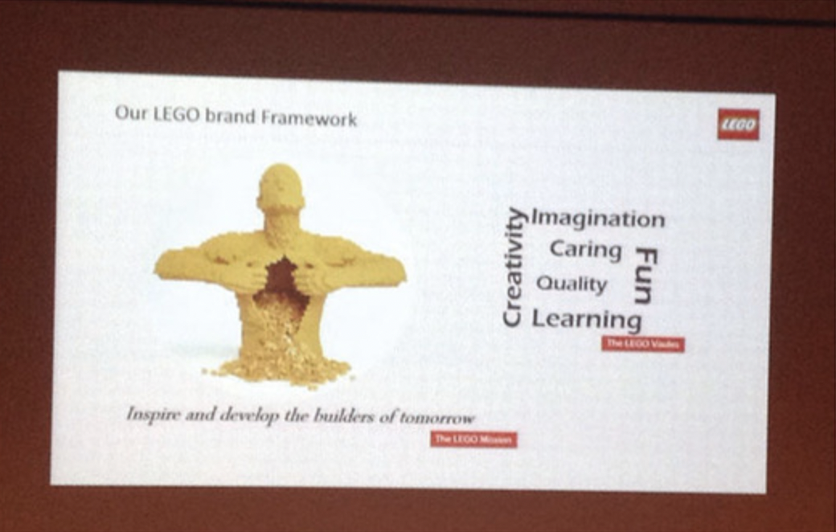

The LEGO Friends series, for example, was subject to accusations of perpetuating traditional gender stereotypes and role behaviours. Made primarily in pink and purple, the characters in the Friends range break the design language of the brand’s traditional blocky figurines, while the sets feature various suburban at-home situations such as cooking, caring for animals, equestrianism, pop stardom, and romance. The range was positively received by the target market, being one of the most successful launches for the brand ever, but earned the ire of parents and feminist critics who started a petition in 2014 calling on LEGO to embrace gender equity.

Similarly, the lack of disabled characters led to #ToyLikeMe online petitions targeting both LEGO (receiving 20,000 signatures) and competitor Playmobil. The essence of these critiques is that brands should be inclusive to all children, regardless of gender and ability, rather than perpetuating stereotypes or reinforcing barriers through exclusion. The brand recognizes that it must move with the times. This is not always easy, as the initial release of a wheelchair-bound character split advocates such as #ToyLikeMe founder Rebecca Atkinson who was delighted with the Lego range figures, stating:

We are beyond happy right now. Lego have just rocked our brick-built world and made 150 million disabled kids, their mums, dads, pet dogs and hamsters very-very happy. ... this move by Lego is massive in terms of ending cultural marginalisation, it will speak volumes to children, disabled or otherwise, the world over. (BBC, January 29, 2016)

However, Atkinson was less impressed with the brand’s DUPLO range (for younger children) with the addition of an old man in a wheelchair, suggesting that having a singular character with a disability created a ‘tokenistic stereotype in its isolation’:

The scant representation of disability in children’s industries has long fallen into three enduring stereotypes, none of which are very positive or promote self-esteem in children with disabilities—the old (grandparents with sticks and wheelchairs), the evil (pirates with patches and hooks as manifestations of wrongdoing) and the sick or medical (the disabled body as broken and fixable with a stay in hospital). (Calderwood, August 4, 2015)

Likewise, the response to criticism regarding gender roles led the brand to launch its highly collectable limited release Science Lab (see Figure), which quickly sold out and generated much praise. Ellen Kooijman, the originator of the lab on LEGO Ideas, stated:

As a female scientist I had noticed two things about the available Lego sets: a skewed male/female minifigure ratio and a rather stereotypical representation of the available female figures. It seemed logical that I would suggest a small set of female minifigures in interesting professions to make our Lego city communities more diverse. (Criado, August 5, 2014)

Lego Science Lab

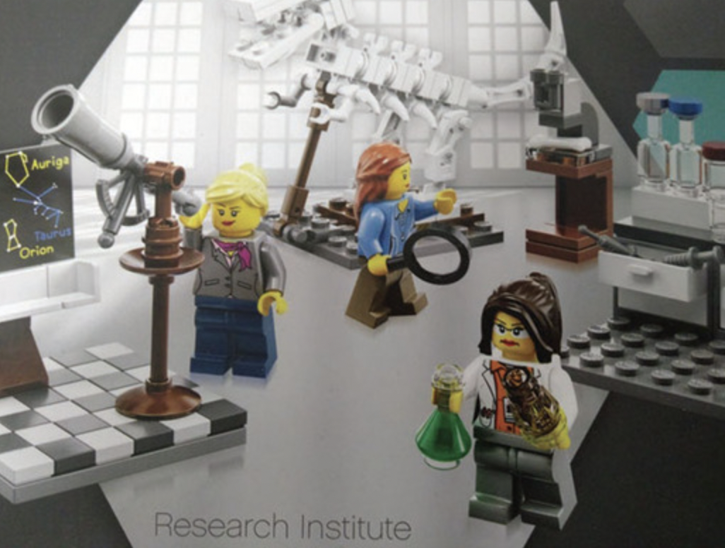

The lab featured several female characters all engaged in various scientific pursuits (astronomy, chemistry, and archaeology), controversially wearing make-up (something that generated heated criticism afterwards). However, speaking at an innovation conference in Copenhagen in 2014, LEGO’s brand manager noted that the range was a big hit with parents and adults, but not so much with children, who still preferred their pink and purple Friends. Admitting the issue was a difficult one that the firm struggled with, the brand manager ultimately sided with young girls, although did not rule out further developments such as the Science Laboratory.

**Case Questions**

1. What strategies have characterized LEGO’s enduring brand success?
2. How does LEGO’s changing practice in relation to co-creation reflect shifts in our understanding of brand management?
3. Why did LEGO attract criticism from various activists?
4. What would have happened to the brand’s image if they had not responded?
5. Evaluate LEGO’s approach to normalizing gender and disability in their product range. Is it too limited?
6. Are they trying too hard or being too overt?
7. What challenges is the brand likely to face from online petitions in the future?

*****************************